**INTEGRATION TESTING**

**Module:** ExitController.java

Import Classes:

* Carpark
* ICarSensor
* ICarSensorResponder
* ICarpark
* IGate
* IAdhocTicket

Implemented Class:

* ICarSensorResponder
* IExitController

Number of Methods: 7 and one constructor

Use Case:

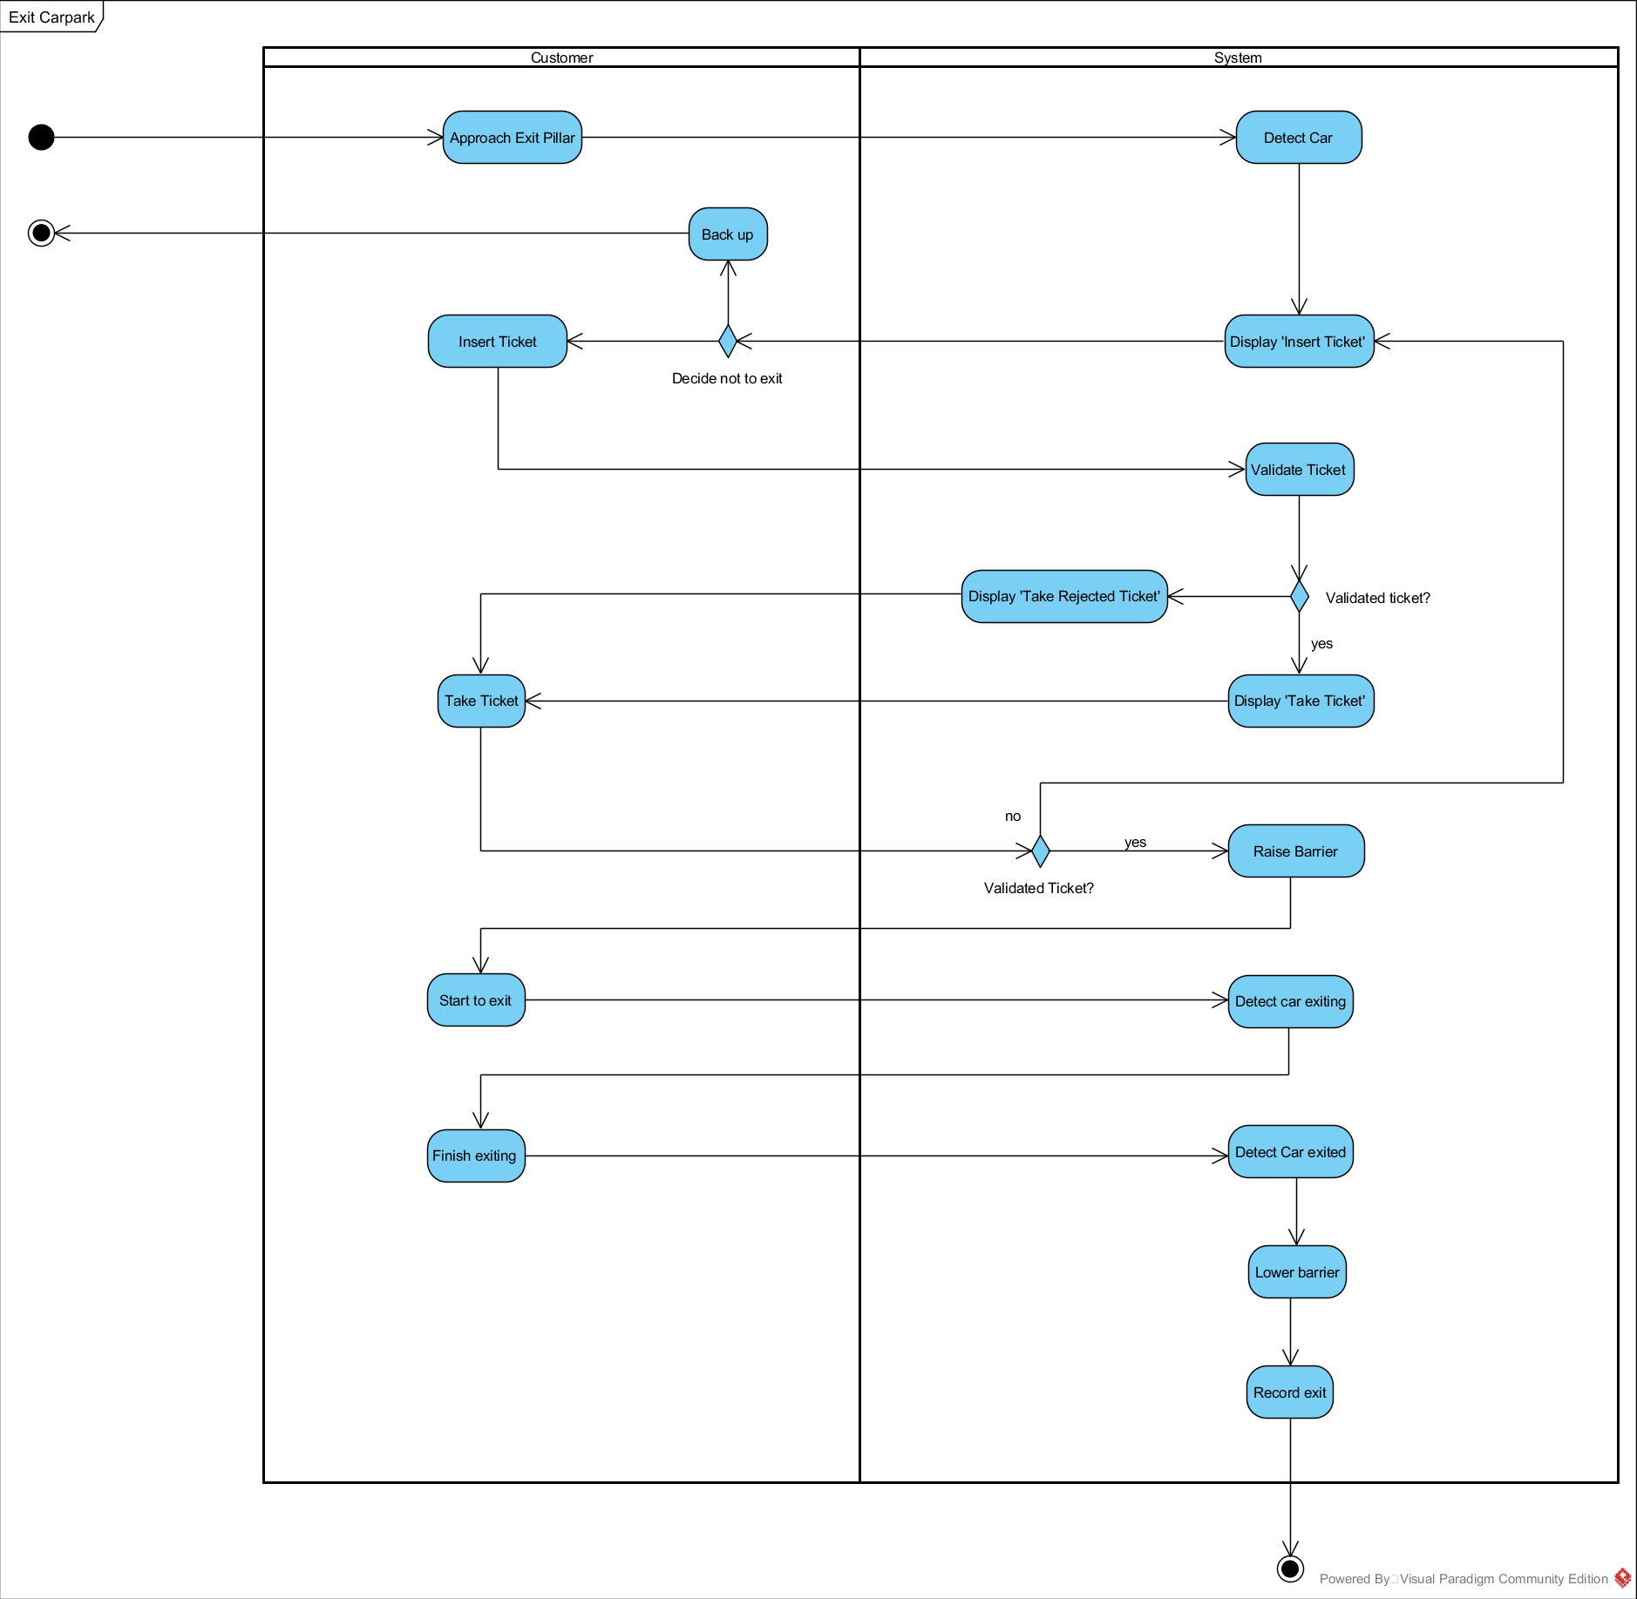

Exit car park activity

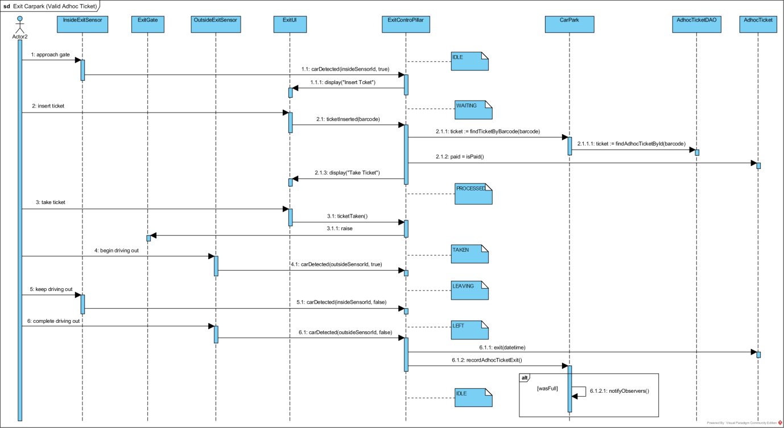

Exit car park valid adhoc ticket

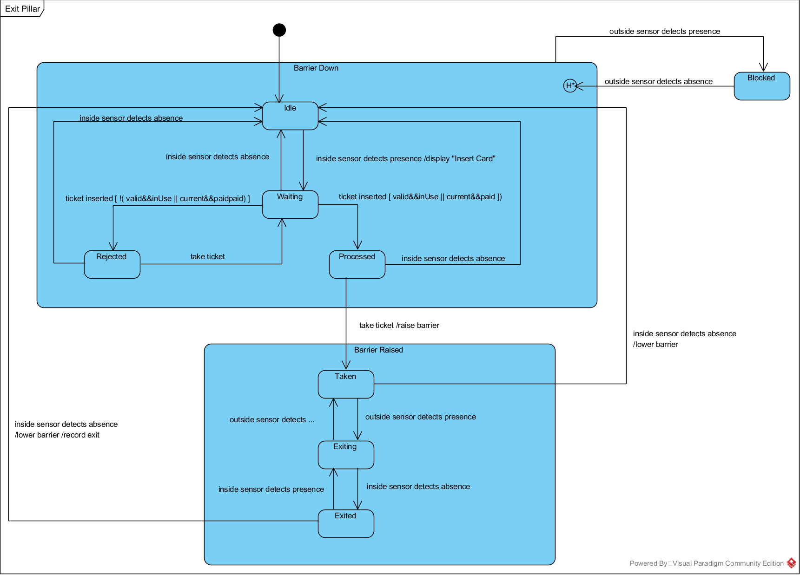

Exit pillar state

Screenshot of Exit Pillar GUI (Running in NetBeans)

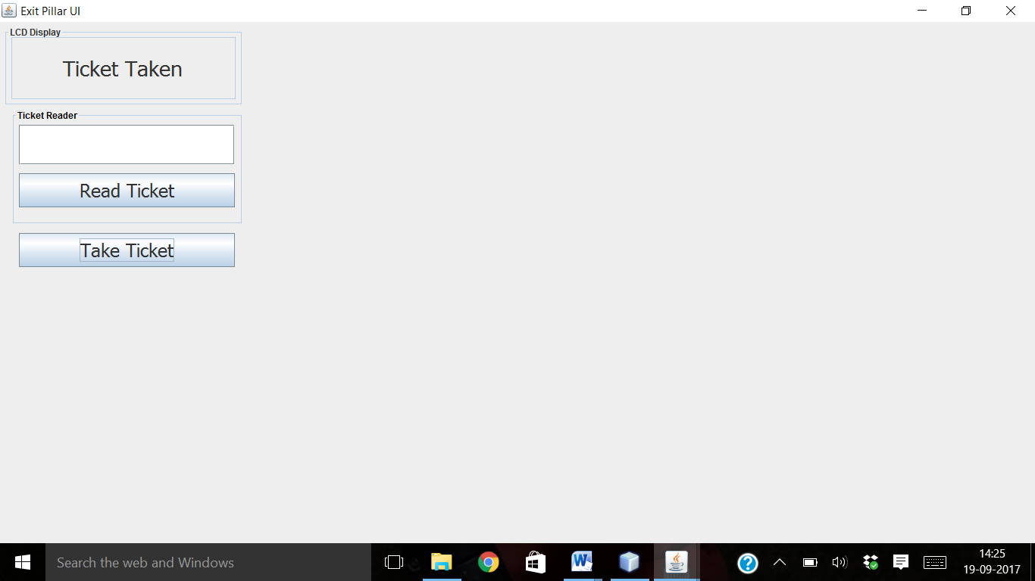

As it read the ticket by the ticket reader, then it show valid message in LCD display as well as rejected during invalid ticket.

**Invalid Ticket**

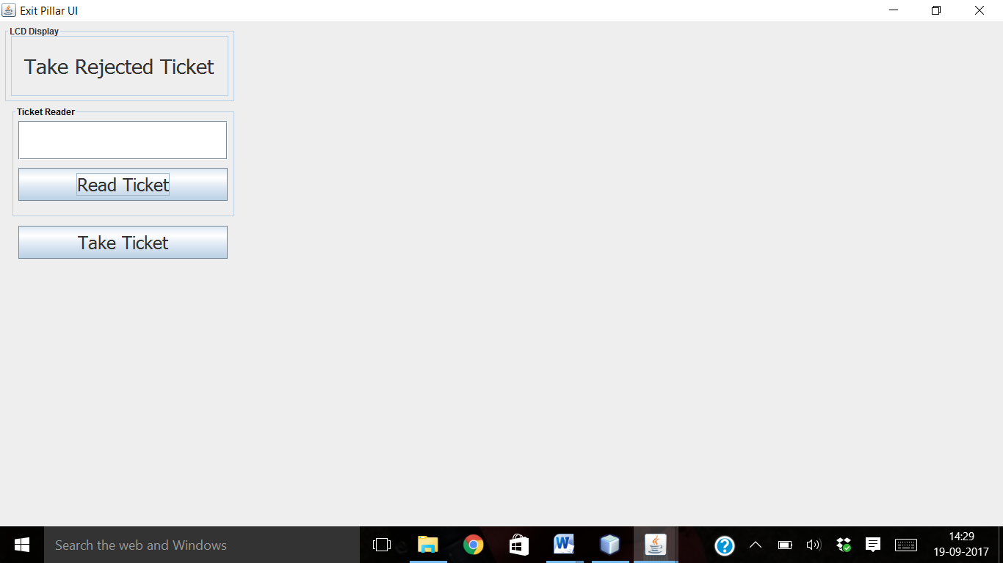

Insert Ticket

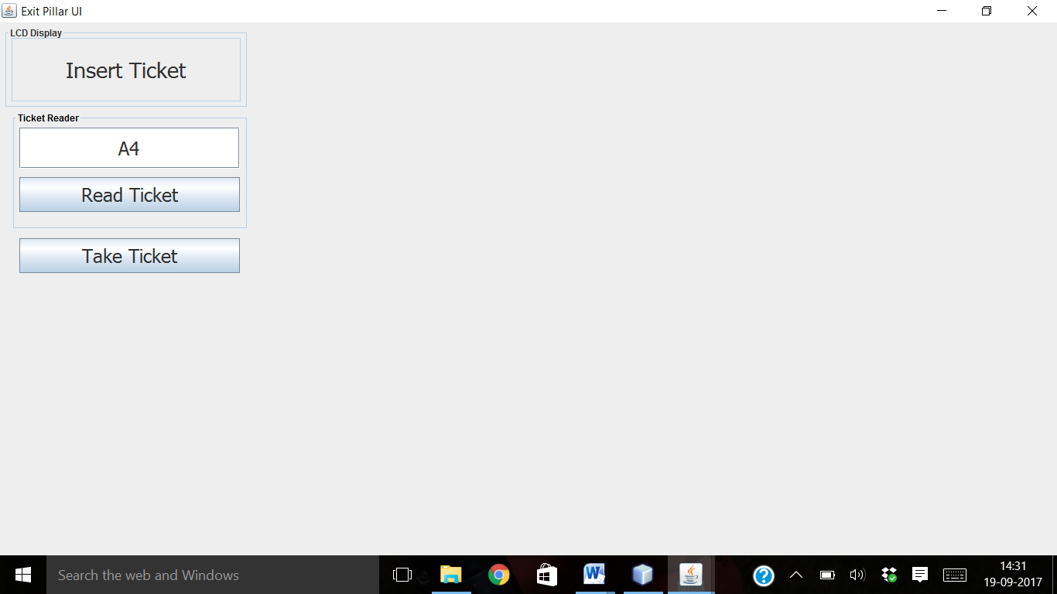

Valid Ticket

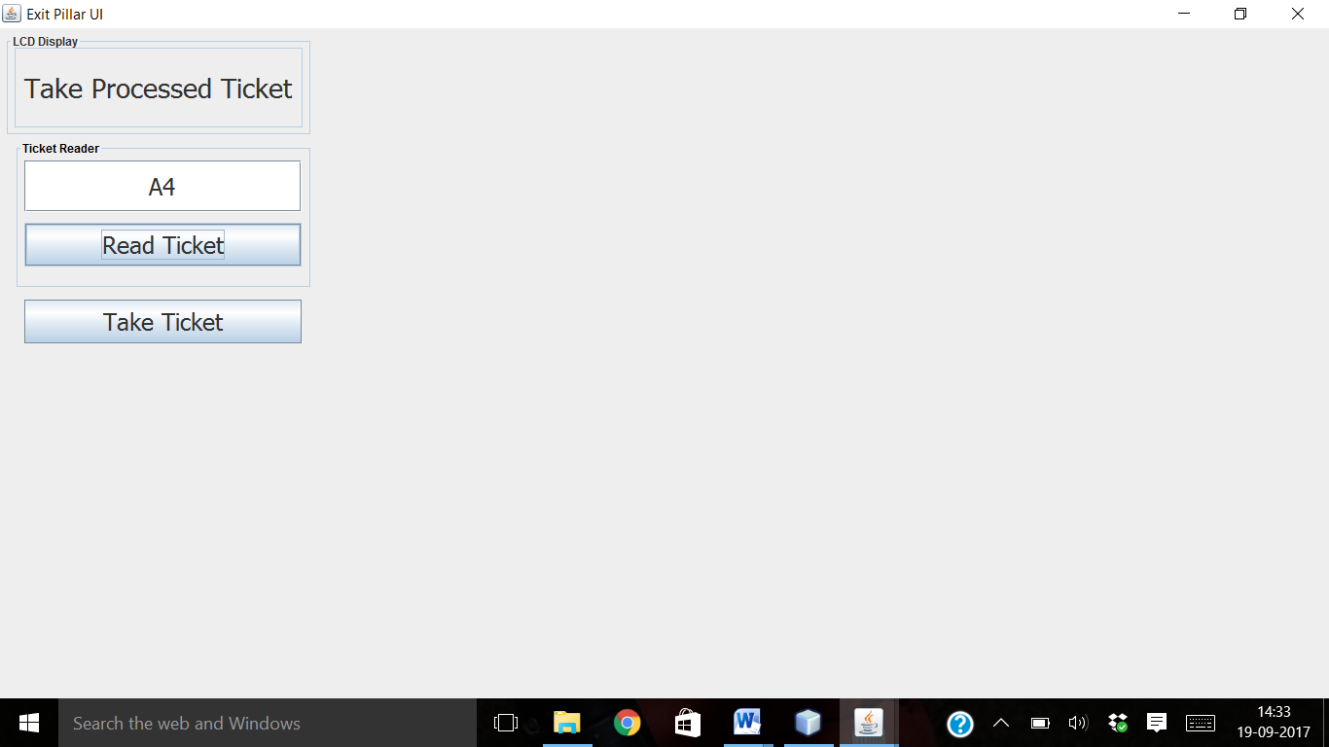

As inside exit sensor on then it demand ticket. After validation of ticket, it raised the outer gate for exit from car park.

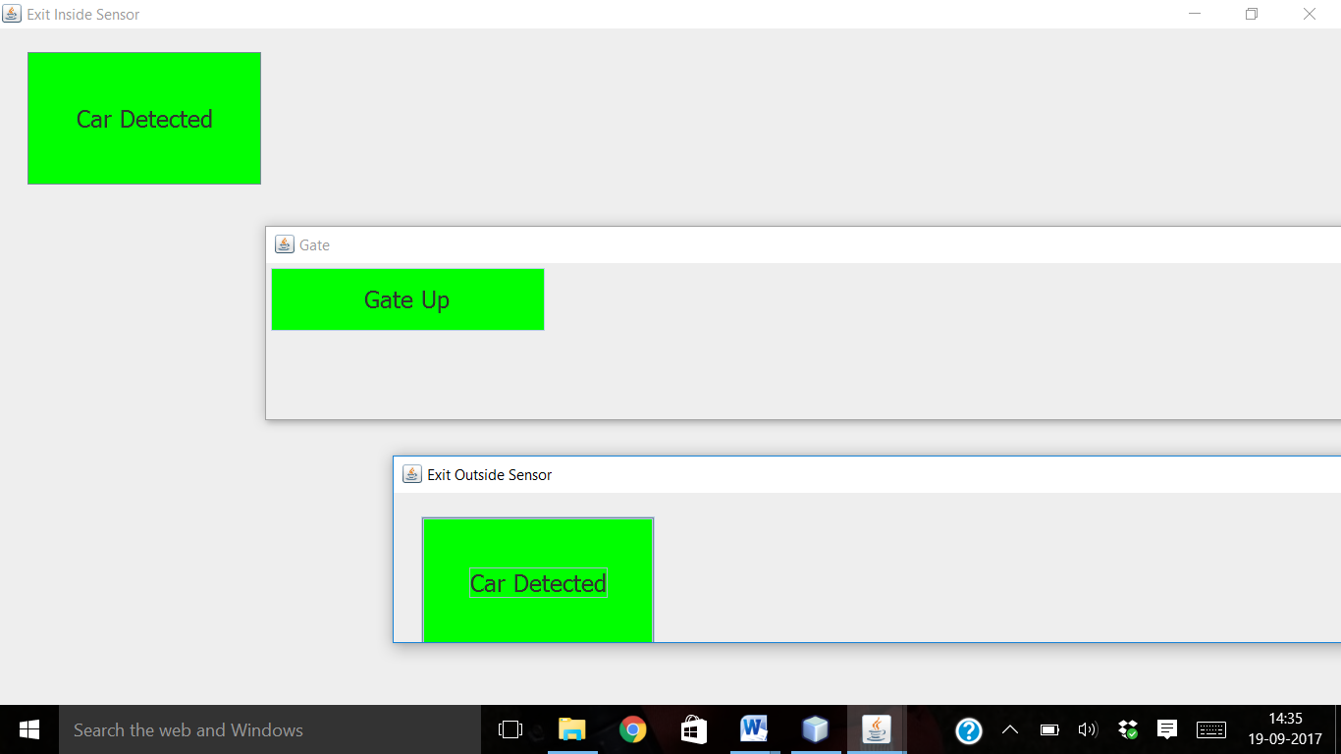

Tested Status:

|  |  |  |  |
| --- | --- | --- | --- |
|  | | **Testing Status** | **Bug** |
| **Modules** | ExitController.java | Done | 22 |
| **Implement Class** | ICarSensorResponder  IExitController | Done  Done |  |
| **Import Classes** | Carpark  ICarSensor  ICarSensorResponder  ICarpark  IGate  IAdhocTicket | Done  Done  Done  Done  Done  Done |  |

**Running in command mode**

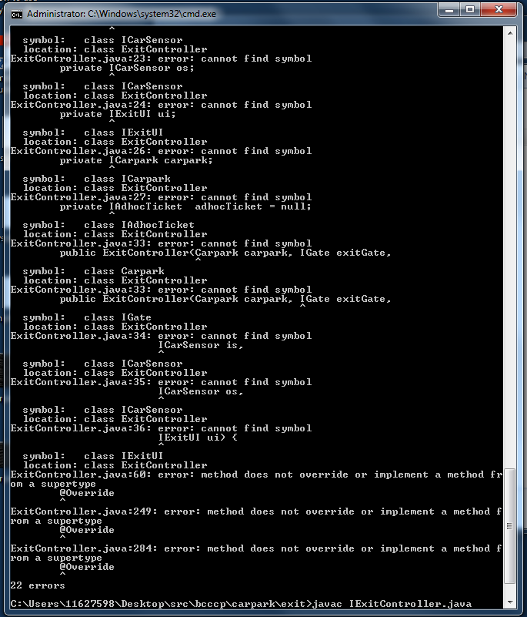

ExitController.java